HSDK board

Create certificate.
- Get UID (UART or JTAG)
UART
- Open a terminal emulator and configure the channel
- Set switches in UART mode (0010 0010) and power ON the board
- Copy 64 characters before CC at the end of string.
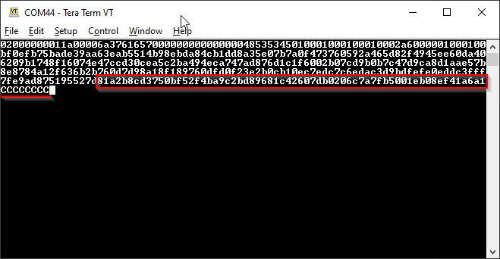

JTAG
- Open J721S2_secure_getuid.cmm and run the script.
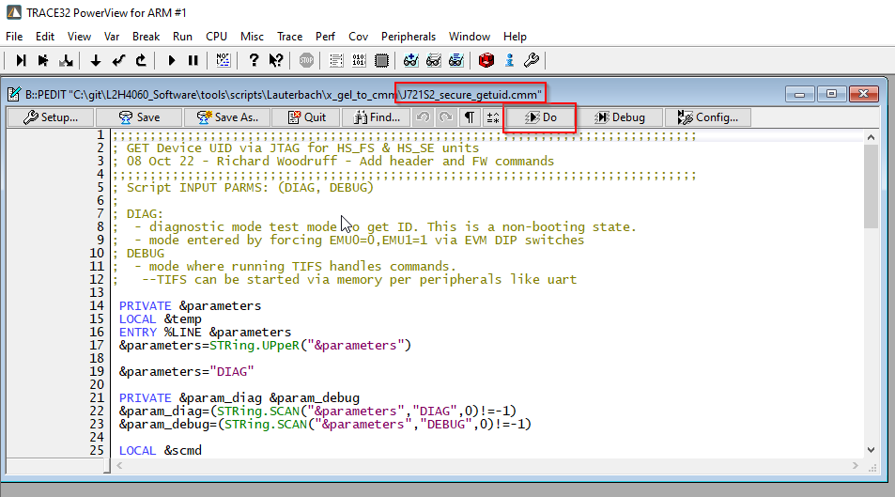

**Be sure you have latest version
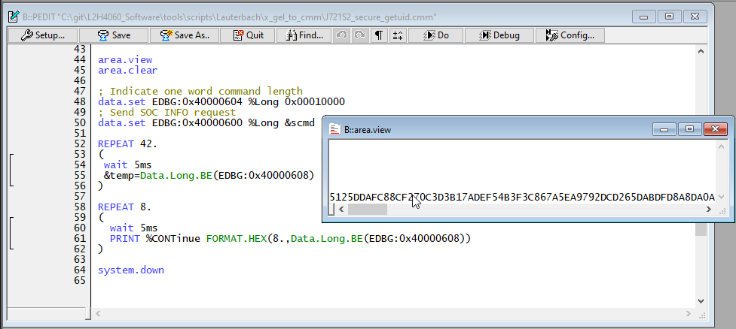

**Sometimes it requires to run the script more than once because the string returned is only 4 bytes written 8 times instead of the complete UID.

- Add UID to x509_debug.txt and x509_flash.txt
- Fill debugUID field in debug extension
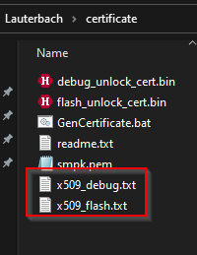
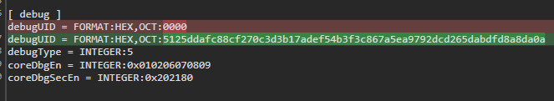

- Run batch file {REPO}\tools\scripts\certificate\GenCertificate.bat
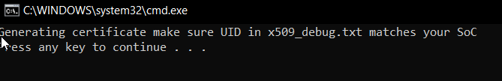
*** This step requires openSSL installed.

Place binaries

- Gather binaries into input folder.
** {REPO}\tools\scripts\Lauterbach\PostProcessBinaries\Input
- Run post process batch file
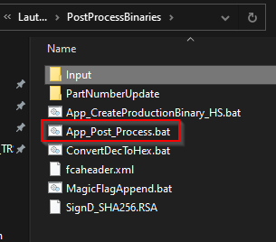

Run flash batch file

**T32 required, by default requires the patch installed. Follow the document in PTC if required.
https://magnalm-prd.ptcmscloud.com:7001/si/viewrevision?projectName=%23/L2H4060%23KP03_ProductEngineering/95_Tools/Lauterbach&selection=How_To_Install_Trace32_for_Lauterbach.docx

Set switches in No Boot mode (0010 0001), power On the board and run LaunchFlash.bat
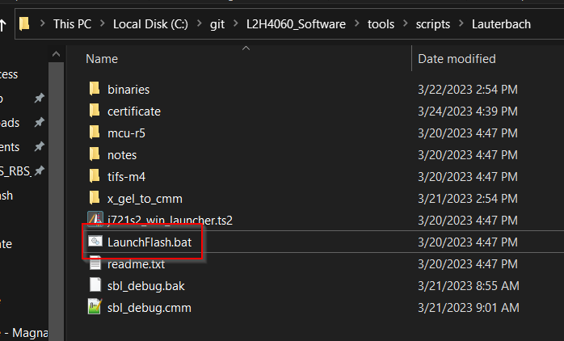

Select HS-DK and click Start Flash button
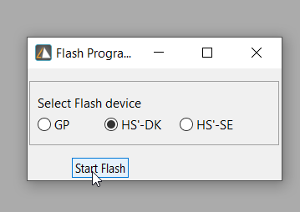

Power down board and click OK
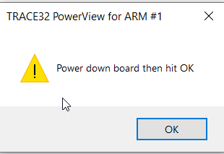
Power UP the board and click OK
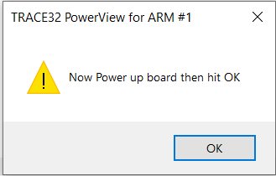

When all the binaries are flashed a message will appear at the bottom asking for power cycle.
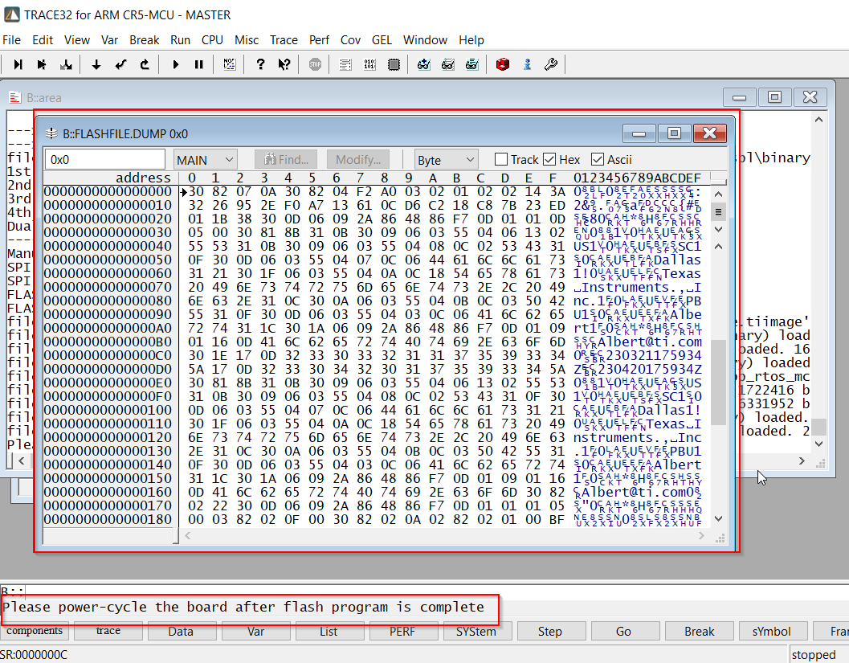

**Before powering ON, change switches to NAND OSPI mode (0000 0010).

